# IOT BASED SMART CROP PROTECTION SYSTEM FOR AGRICULTURE

TEAM ID : PNT2022TMID40963

# Introduction

Many of the farmers are facing a lot of problems while protecting fields during night times. Since protecting the field 24/7 is difficult for farmers. Watering the fields at regular intervals is necessary from increased crop production. Since farmers are very important for the food production it is important to reduce the work of the farmers. Precision Agriculture improves productivity increasing yields and profitability, reducing impact on environment. These days, Internet of Things is playing a crucial role of transforming Traditional Technology from homes to offices One of the main reasons where 10T based research is going on and new products are launching on everyday basis to make the activities smarter and efficient towards better production in "Agriculture".

10T based agriculture convergence technology creates high value in terms of quality and increased production and also reduces burden on farmers in ample manner. In addition to Agricultural lot, the future of agriculture is "Precision Agriculture" which is expected which is expected to grow at $3.7 billion by 2020.

With data generated from GPS and Smart Sensors on agricultural field and integratuion of smart farming equipment along with the Big Data analytics, farmers would be able to improve crop yields and make effective useof water and in turn wastage of any sort would be reduced to a remarkable level. The current scenario of agriculturewhich is surrounded by many problems, it is utmost requirement to have 10T based Smart Farming. In order to implement smart farming in real world,

Design Methodology

Adaptors for power supply. Arduino Uno is used to interface sensors with Wi-Fi module and GSM module. Initially data is sensed by the sensor and the data is sent to the Arduino. Arduino uses the Wi-Fi module to connect to the Thing Speak platform where we can see the sensor values in the form of a graphical chart. GSM module is used to send messages to the farmers mobile to alert.

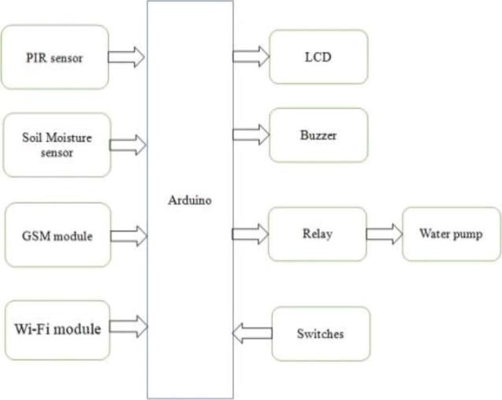

# FIG: BLOCK DIAGRAM

A LCD display is used to display the functioning of the project. PIR sensor is used to avoid the entry of animals. They are placed around the field to detect the motion. Whenever PIR senor detects motion, a signal is sent to the Arduino. Then Arduino activates the buzzer to produce sound. The data from the sensor is sent to the Thing Speak platform by using API keys. Arduino also sends a message to the farmers mobile indicating that animals were trying to enter the field. Soil Moisture Sensors used to find the moisture of the soil. By detecting the moisture and if is below the required level then Arduino sends a message to the farmers monile indicating that it is required to water the field. The farmer then sends a message to switch on the motor. Whenever the supplied water is sufficient Arduino sends another message to tell the farmer to switch off the motor. Farmer then switches of the motor by sending a message to the GSM module.

# Implementation:

Algorithm

The following steps involved in implementation:

1. Code for interfacing Wi-Fi module and GSM module to Arduino.
2. A message is sent to the GSM module to register the farmer.
3. Once the message is sent the program goes into infinite while loop.
4. Whenever PIR sensor detects any type of motion around the field, a buzzer sound is played.
5. A message is sent to the farmers mobile saying tat animals were trying to enter the fields.
6. Whenever the moisture of soil is less than threshold value then a message is sent to the farmers mobile.
7. The farmer on receiving the message will send message" on" to turn the motor on.
8. When sufficient water is supplied, another message is sent to farmers mobile saying to stop motor.
9. Farmer will send a message "off' to turn off the motor.
10. The values of the sensor are uploaded in Thing Speak platform for every 10 minutes.
11. LCD is used to display the functioning of project at any given time.

# FLOW CHART:

When the power is supplied to the Arduino board, Wi-Fi module is RESET and the connection is established between the ESP8266 module and local Wi-Fi network

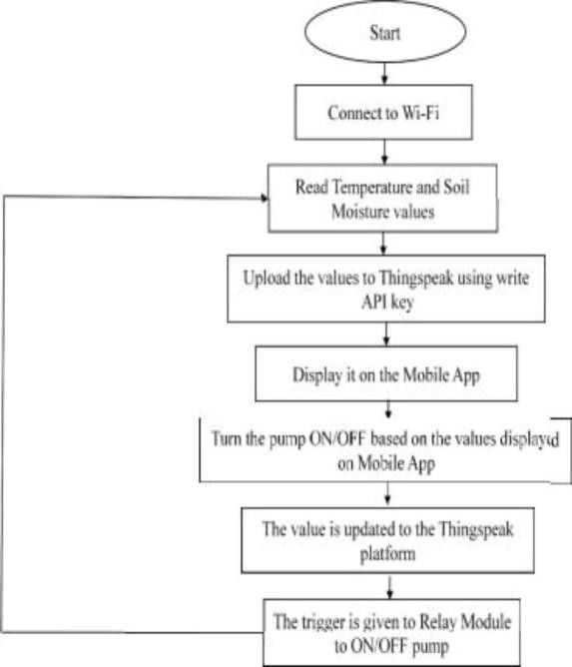

## Results and Discussions:

In this smart agriculture farming designed and implemented by using IOT. Thing Speak platform is used in here to display the values of sensors and implemented in interactive way by knowing about the functioning of the project through SMS with the help of GSM module.

## Water Supply Monitoring:

### One of the important task of the project is to monitor water supply. This can be done using Soil Moisture sensor andDC Motor. Whenever the moisture level is below 50, a message is sent to 26 the registered mobile. After receiving the message, the user sends a return message as „MOTOR ONee to turn on the motor for

supplyingwater. When the motor is turned on it is shown on LCD screen . When the motor is turned on a message is sent in return as „USER REQUEST MOTOR ON "When the soil moisture value becomes more than 50, a message is sent to farmers mobile.

## Movement Detection:

Two PIR sensors are used in this project to detect entry of animals and other living organisms during night time. One of the them is named as „WEST PIRee and other is named as „EAST PIR". Whenever the PIR sensor detects any motion around it sends a message to the users mobile with the name of PIR sensor. The values of PIR sensors are displayed on the LCD.

Whenever PIR sensor detects any obstacle the PIR value is sent to the server. A messageis sent to the mobile saying that sensor has detected. Similarly, when EAST PIR detects any movements, a message is sent to user.

# Conclusions:

In this work, a design and implementation of Smart Faring using IOT has been proposed. This system is able to collect the information about the main environmental parameters such as; Temperature, Humidity and soil. The whole system is advanced, reliable and convenient. This design improves the real-time performance of the user to the agricultural environment change, and is conducive to the realization of the unattended goal, and promotes the development of the intelligent Agriculture system. In future, this scheme can be used as a part of the development of remote monitoring of the Internet of things and can be applied on other areas of modern facilities agriculture, In future, instead of the ARDUINO UNO microcontroller, we will use the Raspberry Pi 3 microprocessor. It has the in-built Wi-Fi module. So that there is no need of the external Wi-Fi module so that we can reduce the hardware complexity.